 | Weekly Team Task Report | #2

Team: GeoLearn |  |  |  |  |  | Date: 10/3/19
Project Title: Improving elementary education with custom online enironmental science lectures

 | Samuel Prassse  Present  On-time | 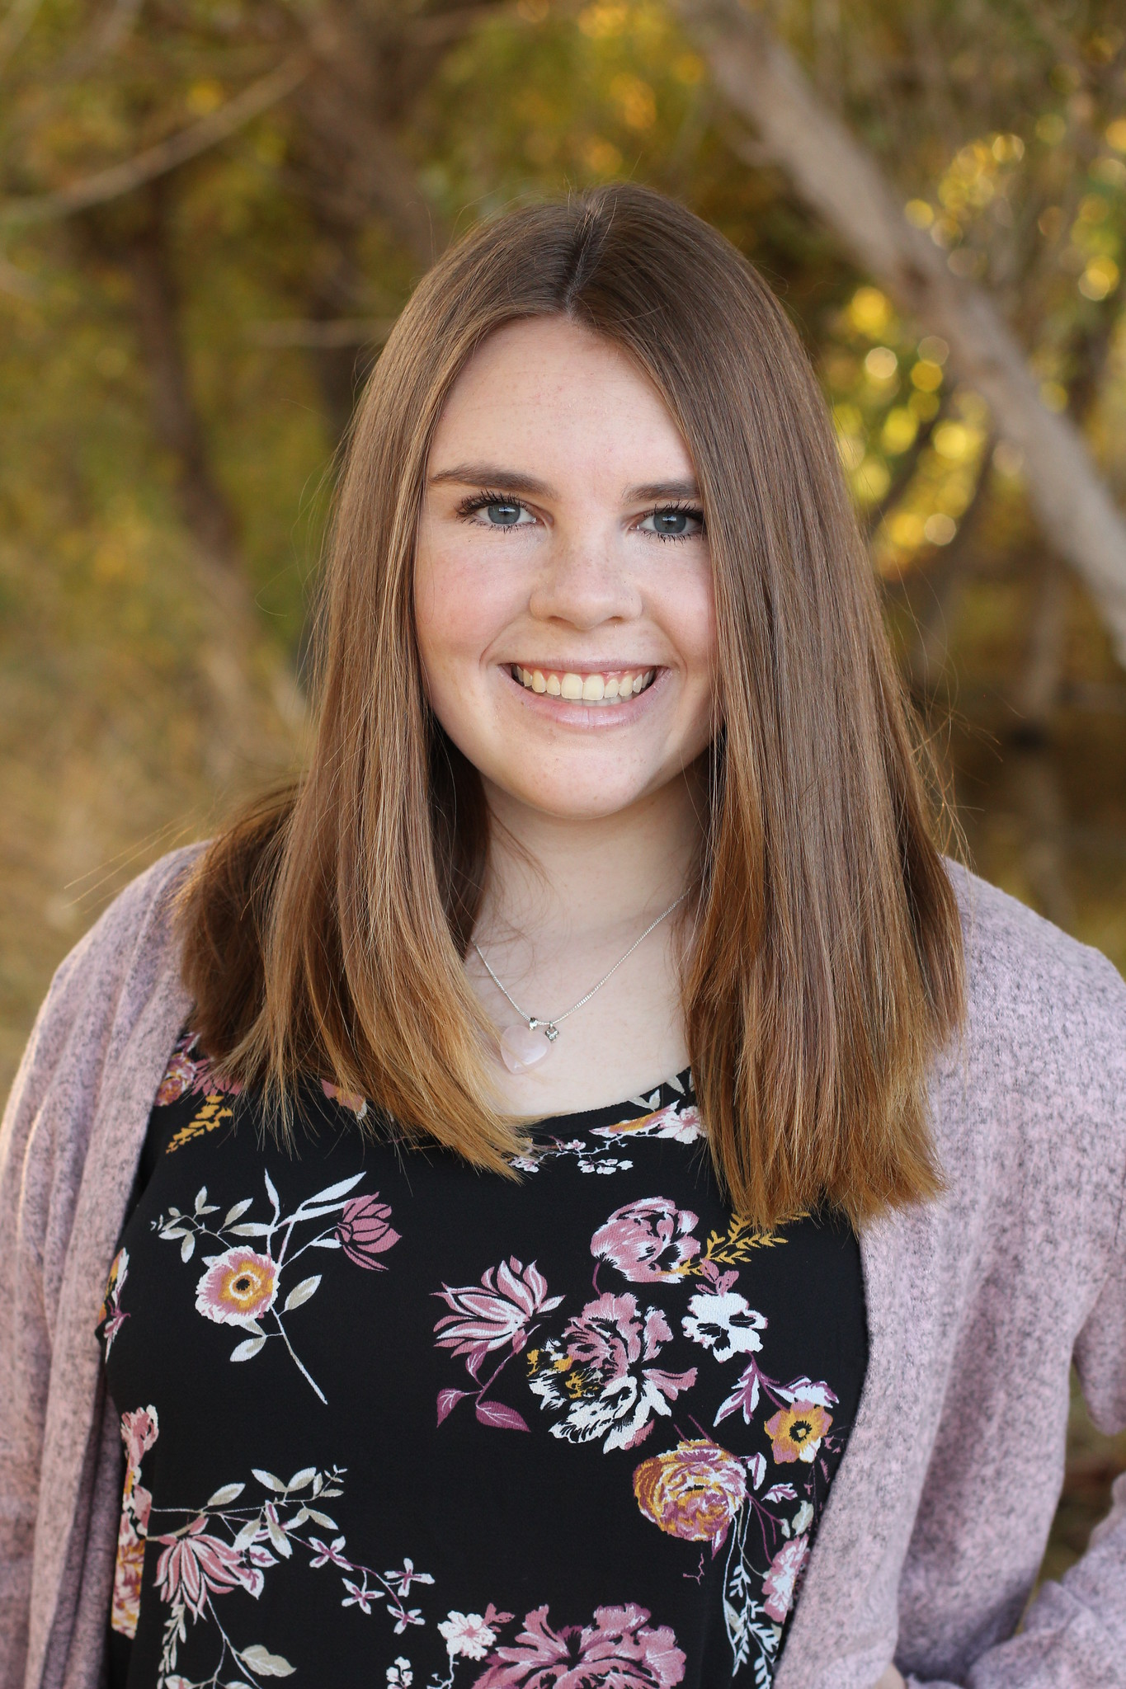 | Kaitlyn Grubb  Present  On-time | 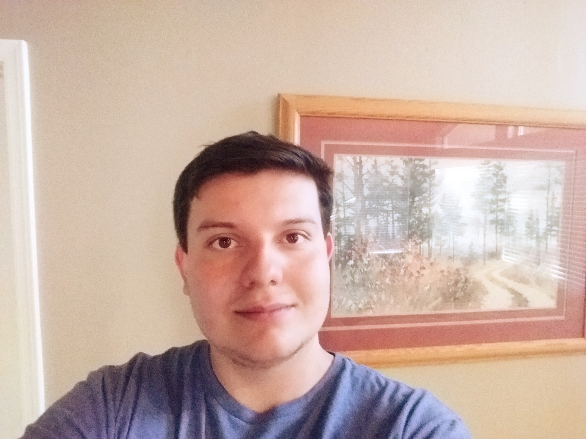 | Tyler Pehringer  Present  On-time |  | 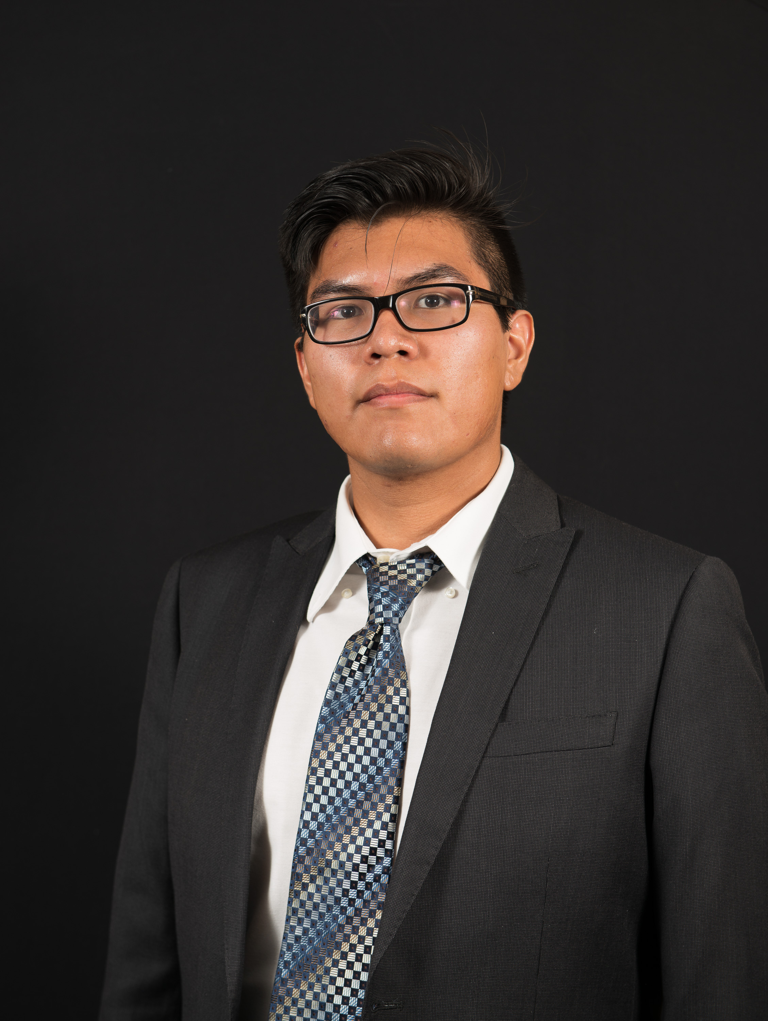 | Joshus Tenakhongva  Present  On-time

Recent Meetings:
- General Team Meeting

TASKS COMPLETED since last meeting:

Task Title: Setting up the team website | Task Initiation: 10/1 | Orig. Due Date: 10/3 | Status: Completed
Who (%): Joshus (85%), Samuel (5%), Kaitlyn (5%), Tyler (5%)
Description: We were assigned this task to create a space where we can store all our pertinent documents and information. We uploaded a basic index.html to our website link to ensure we had a connection and were able to manipulate the page. This page contained our project name, team name, logo, and team members. After this was accomplished, the team leader sent an email to the Capstone Organzier containing the name of our team, and the link to the functioning website. We did this to signal Dr. D that our website URL is live and can be linked from the Teams page for universal access across the course.
Expected Outcome: A barebones website containing basic yet vital information to the team. Basis of our team documentation.

Task Title: Mini-Intro | Task Initiation: 10/1 | Orig. Due Date: 10/4 | Status: Completed
Who (%): Joshus (25%), Kaitlyn (25%), Tyler (25%), Samuel (25%)
Description: The goal of this task was to create a short 5 minute presentation on our project to present in class on Friday. We are required to introduce the team, the name of the project, and our CS faculty mentor. We must “hook” the audience with a great intro, introduce the client, explain what “is wrong” ergo the problem, and our solution to the problem. We will then present the class with our Plan For Development which will include a few bullet points on requirements and our process to tackle the challenge.
Expected Outcome: To present to the class a short but sweet presentation detailing our project and our plan to complete the task given to us by our sponsor.

This week’s Tasks: Work plan for coming week
Task Title: Fully initialized team website | Task Initiation: 10/1 | Orig. Due Date: 10/15 | Status: In Progress
Who (%): Joshus (25%), Kaitlyn (25%), Tyler (25%), Samuel (25%)
Description: This version of the website will be close to the completed version that we are looking for. This version will contain clean and concise HTML and CSS so that the version can be ported and survive the tests of time. This site will be a hub for all of our documents that our Sponsor, Organizer, and Mentor will be able to access at any time, eliminating the need for emailing documents.
Expected Outcome: Funtioning and good looking website containing our team, sponsor, and project information. Look fantastic.
Task Title: Lecture: Requirements Acquisition | Task Initiation: 10/11 | Orig. Due Date: 10/11 | Status: Upcoming
Who (%): Team (100%)
Description: Team will be attending lecture on Friday October 11th to learn about Requirements Acquisition. This is a high-level, non implementation specific statement of a software systems’s intended functions or services.
Expected Outcome: Gain vital information that will beneift our team throughout the duration of this project.

Task Title: Discussion: Tech Writing QuickRef | Task Initiation: 10/7 | Orig. Due Date: 10/11 | Status: Completed
Who (%): Team (100%)
Description: This is a discussion on Technical Writing. It will cover Cover sheets and presentations, headings and subheadings, use of bullets, use of diagrams and figures, and white space issues.
Expected Outcome: To learn about technical writing and to apply it to our team documents.

Task Title: Technological Feasibility Analysis | Task Initiation: 10/7 | Orig. Due Date: 10/25 | Status: Completed
Who (%): Joshus (25%), Kaitlyn (25%), Tyler (25%), Samuel (25%)
Description: Create a document describing any technical “challenges” we forsee in our project, and then going through and analyzing each of them: discuss what they are, what needs to be done to tackle it, then outline the alternatives for tackling the challenge, describe what you did to test the alternatives, and end with our well justified decision of which approach yoy plan to pursue.
Expected Outcome: Turn in a bound document of about 5-6 pages and submit it to our CS faculty advisor.

Upcoming Tasks: Planning
Task Title: Peer Eval #1 | Who (%): Team (100%) | Rough Due Date: Friday October 11th
Description: Includes the team inventory/standars and mini-intro

Other Problems / Other Issues:

